Peter Steinhauer, b. 1966

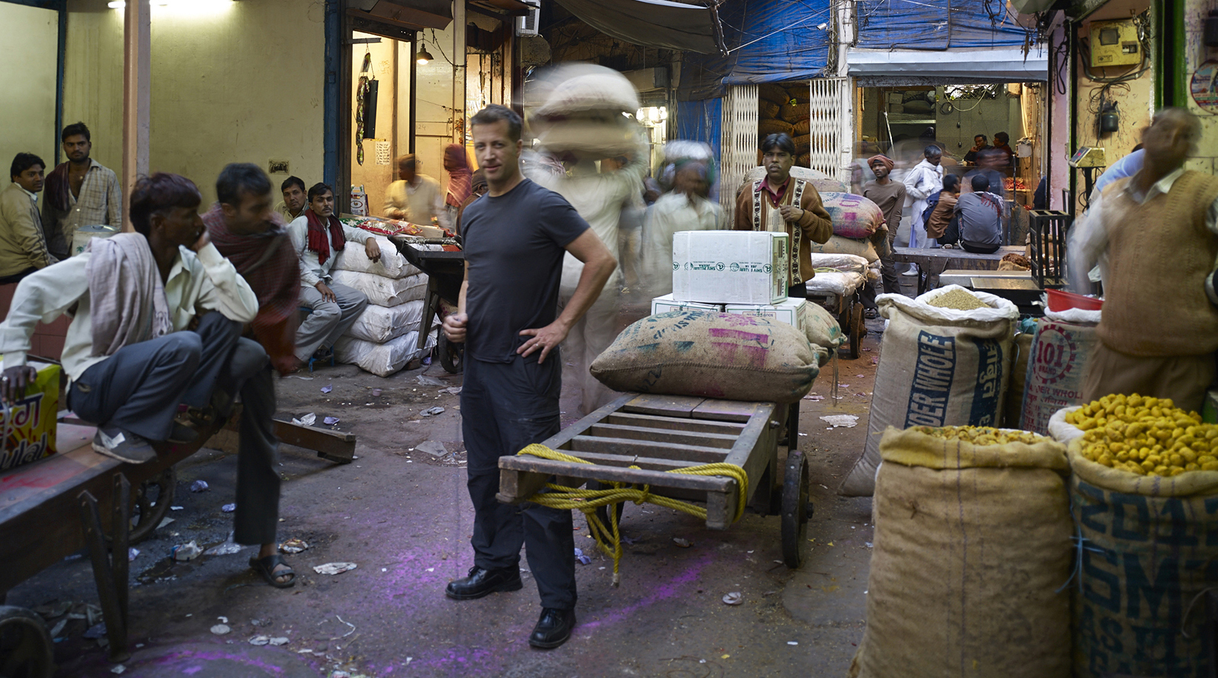

Peter Steinhauer’s photographs are both works of silence and works full of life. Since 1993 he has been documenting the many facets of Asian cultures. Steinhauer focuses on photographing architecture within urban landscape, natural landscape, man made structure and portraits from different countries throughout Asia. His finely crafted prints are exhibited in galleries and museums internationally, and are in private collections of the Carnegie Museum of Art, The Hong Kong Heritage Museum, numerous private and corporate collections, Embassies, and Ambassador’s Residences worldwide. He is also a recipient of numerous international photography awards. In 2014, Steinhauer was nominated as a finalist for the Lucie International Photographer of the Year category and received seven IPA Awards. His Cocoons project was featured in the NY Times LENS and also selected into the 2014 Communication Arts Photography Annual. In 2012, Steinhauer received four IPA Awards and a third PDN Annual Photographic Award of Excellence; 2011, a Black and White Spider Award for Architecture and a One Life Award from PDN. In 2009 he was awarded in numerous categories in the prestigious IPA and PX3 Paris Annual Photography Awards. In 2004, Steinhauer was awarded a Ford Foundation Grant for his work from Vietnam and in 2005, the United States Embassy in Hanoi, Vietnam chose to exhibit Steinhauer’s photographs as part of the Ten Year Anniversary Celebration of diplomatic relations between the United States and Vietnam, which were exhibited at both the Hanoi and Ho Chi Minh City Fine Art Museums. Steinhauer is also a member of the elite Explorers Club in New York.
Steinhauer’s first book on Vietnam entitled, Vietnam: Portraits and Landscapes, was published in 2002. Enduring Spirit of Vietnam, (Forward by Michael Kenna) Steinhauer’s second publication was published in 2007 and was awarded Best Photography Book of the Year 2007 by PDN (Photo District News), and won a Silver Medal in the Independent Publishers Annual Book Awards 2007. Other book projects include, Cocoons, Hong Kong - Surface Unseen, Asian Markets, Bali, and a third on Vietnam.
In 2014, after 20 years of living in Asia, Steinhauer relocated back to the US where he lives in San Francisco with his wife and three children.

